Class: CSCI-3550

Professor: [Harvey Siy](https://unomaha.instructure.com/courses/19493/users/203)

Project title: Online Delivery Services

Pairs:

Zexi Xing will focus on part of server designing, debugging, testing. Also he will take care the HTML page arrangement part.

Yi Liang will work on the network connection between client and server. Moreover she also has the responsibility for common gateway interface(CGI: for transferring user’s request and sending user’s data to our server. After that, our server will create a file to respond user’s request and let user check user’s input).

Our project is a simulation of CGI, we will use the server to imitate CGI program.The CGI is used to generate the order page dynamically based on when user submit form to our server.

Purpose:

We will make a server which can use outside looping network to open a HTML page. And then connect to the server. In the HTML page, there will open a new questionnaire, users are required to fill in some basic information. The server receives the information, and gives some replies. Our project is given to customer who need to online food ordering service.

Functionalities:

1. Can open different thread server and reply.
2. Our interface will have a template to specify input information, so the user can't randomly input whatever they want, and the page also prompt the user to input the correct information.

3.After we collect correct information from user, our server will respond a result page for the user to confirm the information.

Execution scenarios / Message formats:

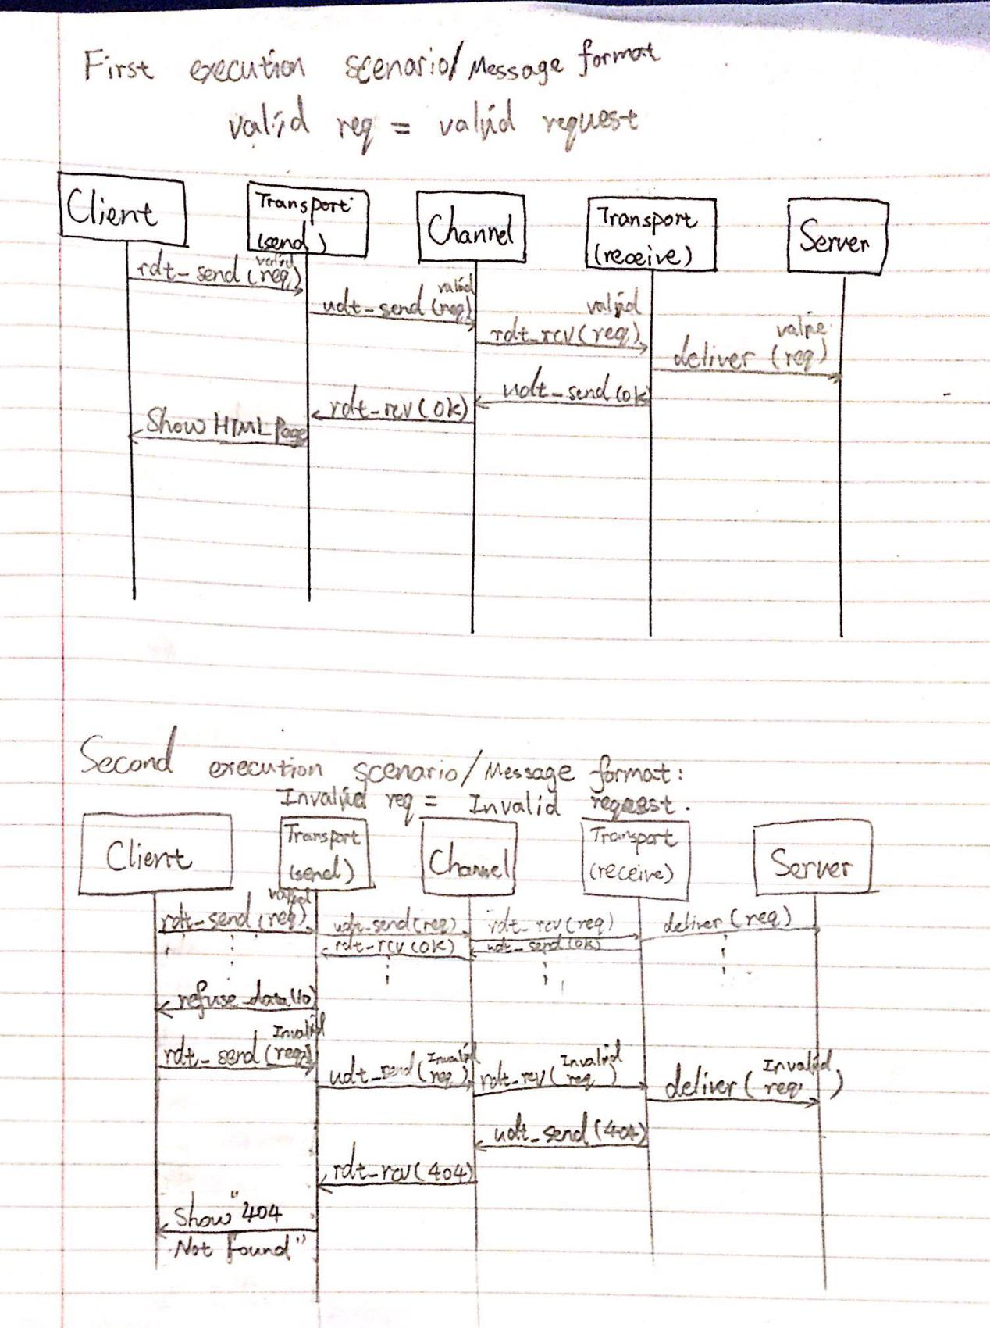

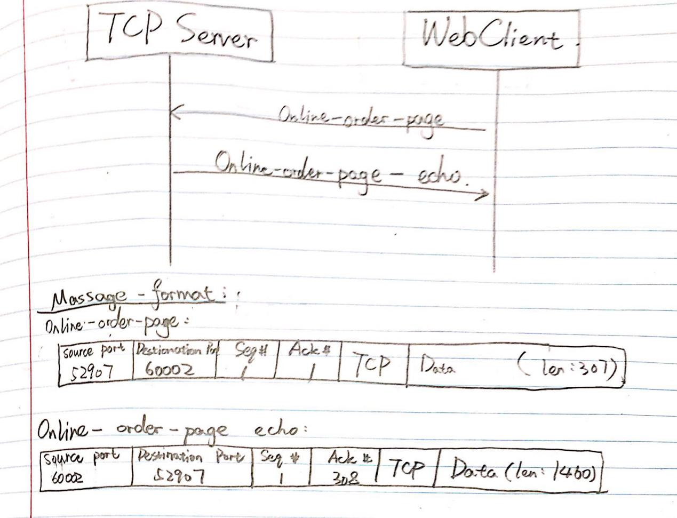

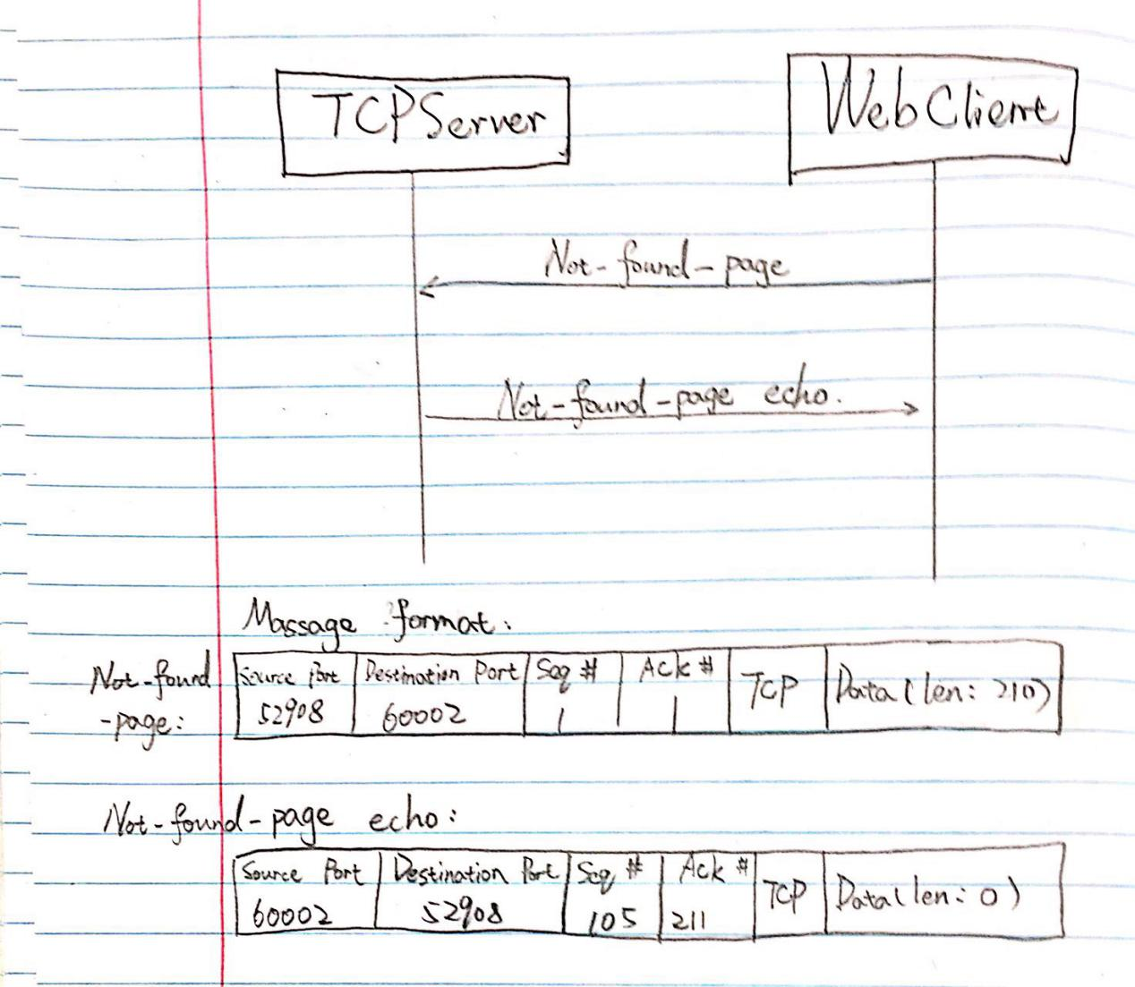

Wireshark packet captures：

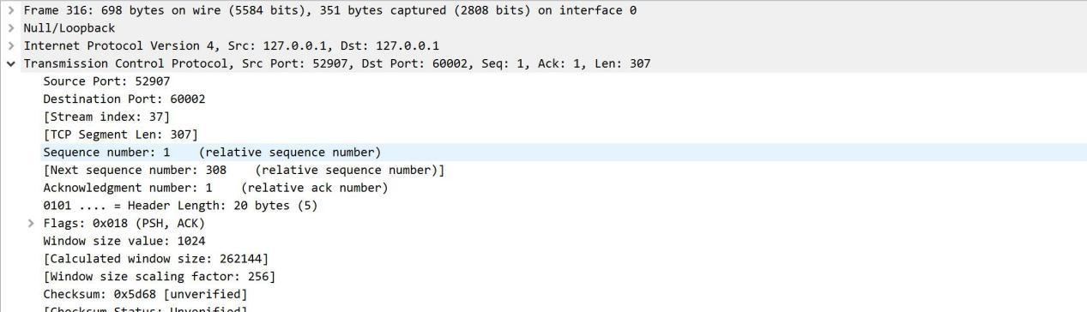

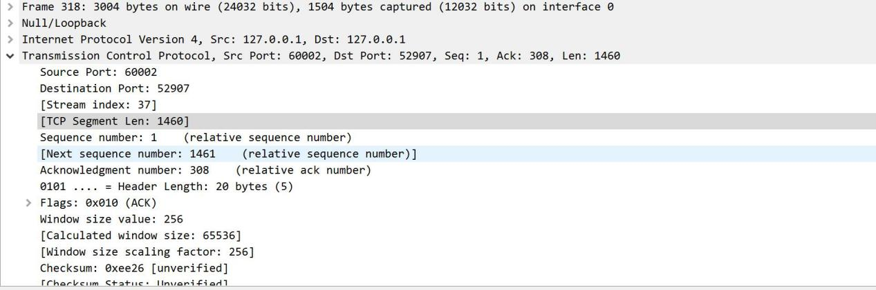

Instructions for setting up and running the applications:

1. . Compiling the program by using” gcc -Wall -ansi -pedantic -o TCPProject TCPProject.c -lpthread”. As a result, we can get the TCPProject.exe program.
2. Running TCPProject.exe by typing ./TCPProject , then use the wired PC to open a browser, which can be Google Chrome or Internet Explorer, after starting web page enter the URL: “http:loki.ist.unomaha.edu:60002/Online.html”(without quotes). Consequently, an online restaurant console.
3. Filling the blanks based on its instructions and hit submit. The web page will reload a new page which shows the confirmation of user’s order details.

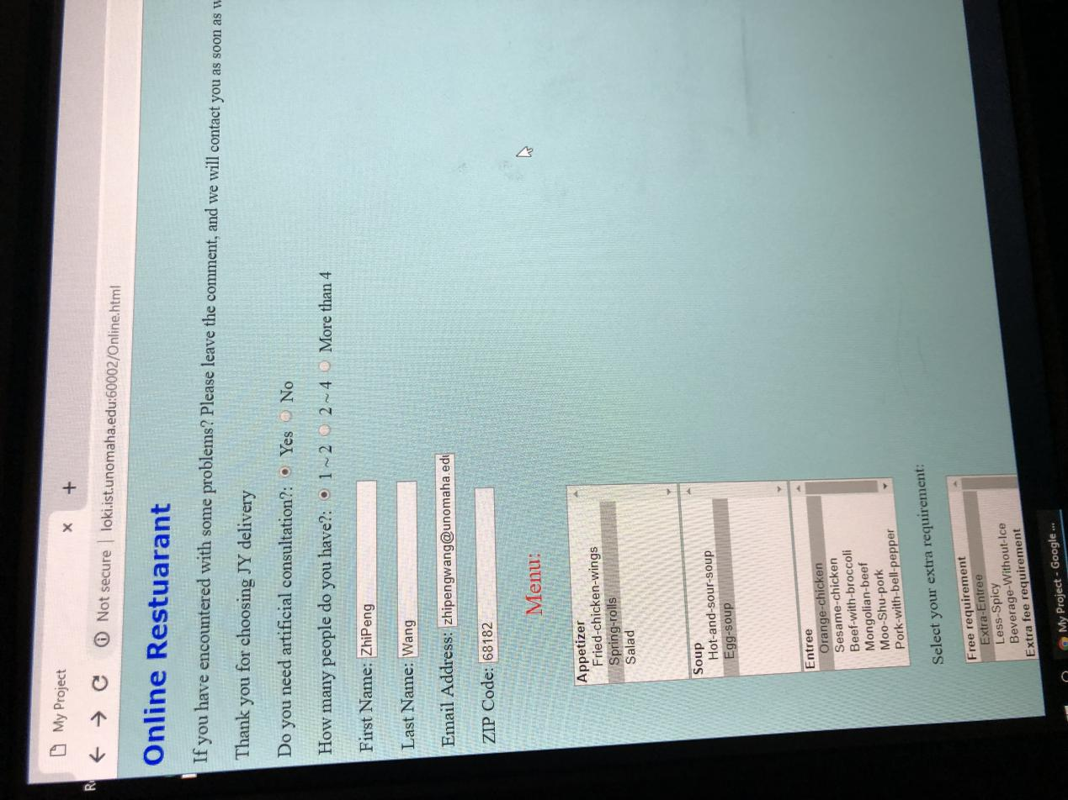

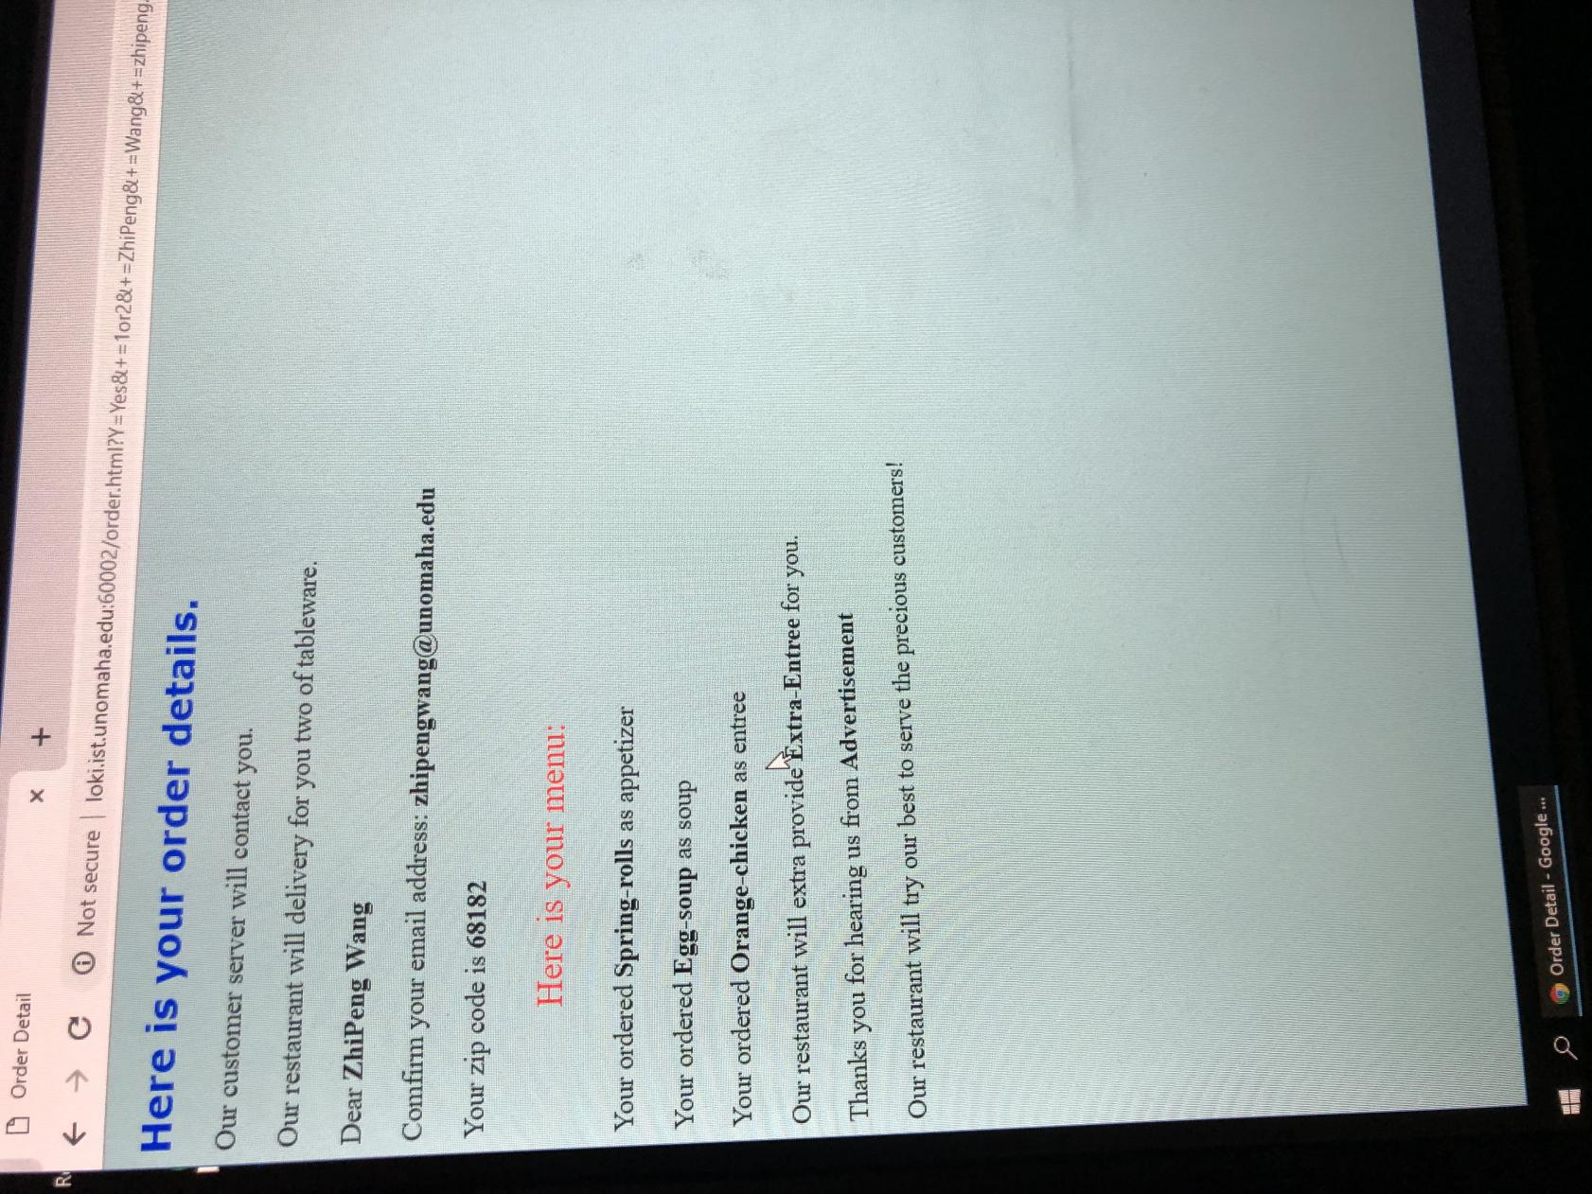

Reflection:

When we started our programming, the biggest problems is that we don’t know how to analyse the user information from web URL. This problem will cause our project can't provide the correct information to the user. After solving this problem, we add some interesting parts. The most interesting part of our project is the user can directly find the information, which he has entered in the Online.html page, are completely showing in the Order.html page. That is amazing!

ZeXi Xing: I have learned how to connect the server with a user’s inputs web page. Furthermore, paring URL ‘get’ request is very difficult to achieve by using server. I need to use complicates structure to take the data based on users input. This is a great programming project to practice our collaboration with using different tools.

Yi Liang: Because in our project, we use HTML page as client. HTML page is very important part of the project. From this project, I have learned how to make a html page and how to use inline CSS.

Link to Github:

<https://github.com/yyliang3/unocsci3550-project>